**Task 1**

## **Illustrate the main function of Microsoft access, demonstrate how to create, save, and delete database files.**

## Microsoft Access is a relational database management system that allows you to create and manage databases. The main function of Access is to provide an efficient and user-friendly way to store, organize, and retrieve data.

To create a new database file in Access, follow these steps:

1. Open Microsoft Access and select "Blank Database."

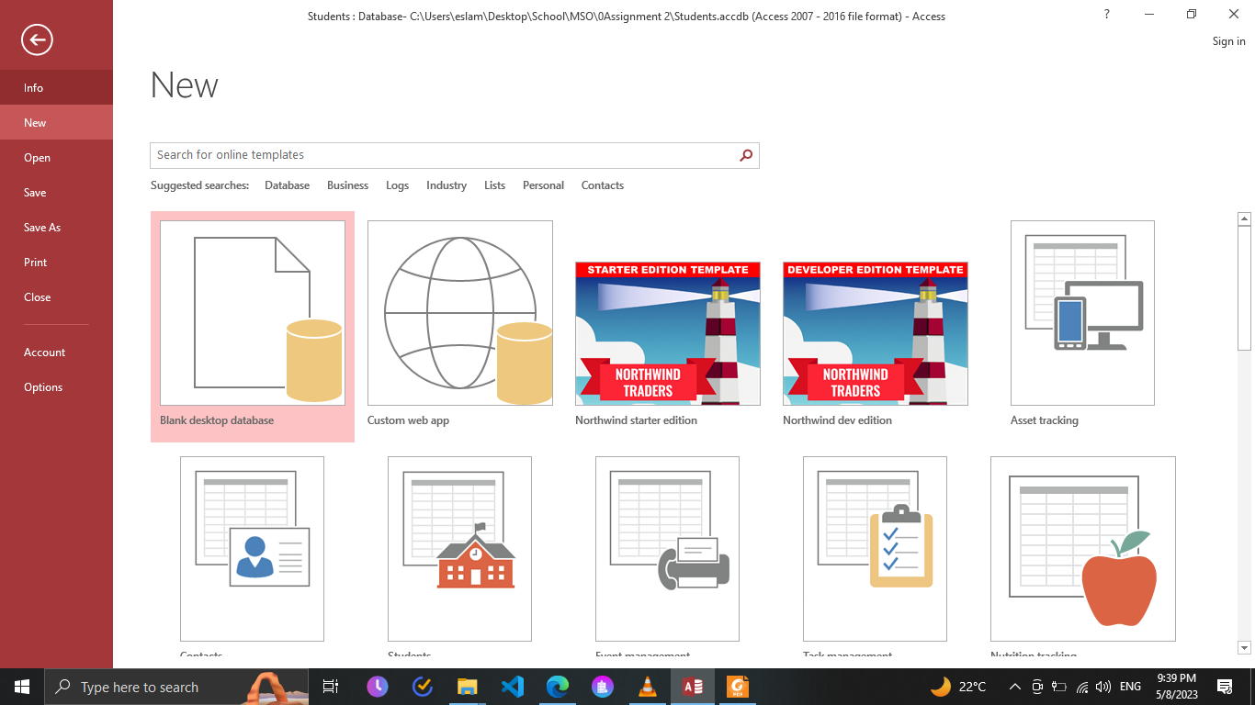

1. Choose a location to save the database file and give it a name.
2. Click "Create" to create the new database file.
3. Create a table

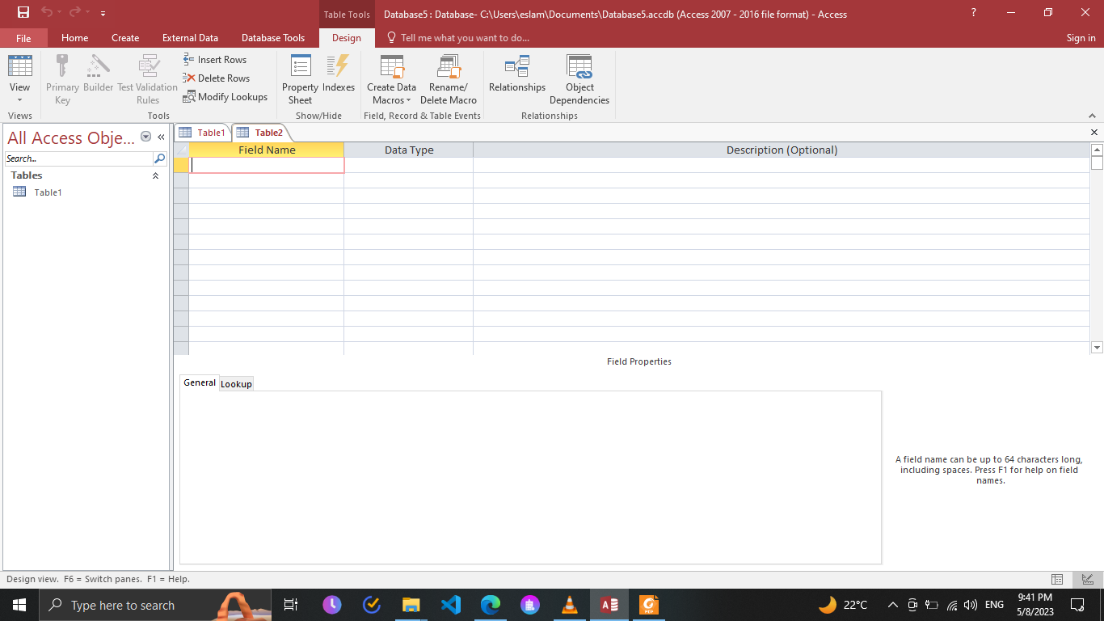

1. Hit Ctrl+s to save the table

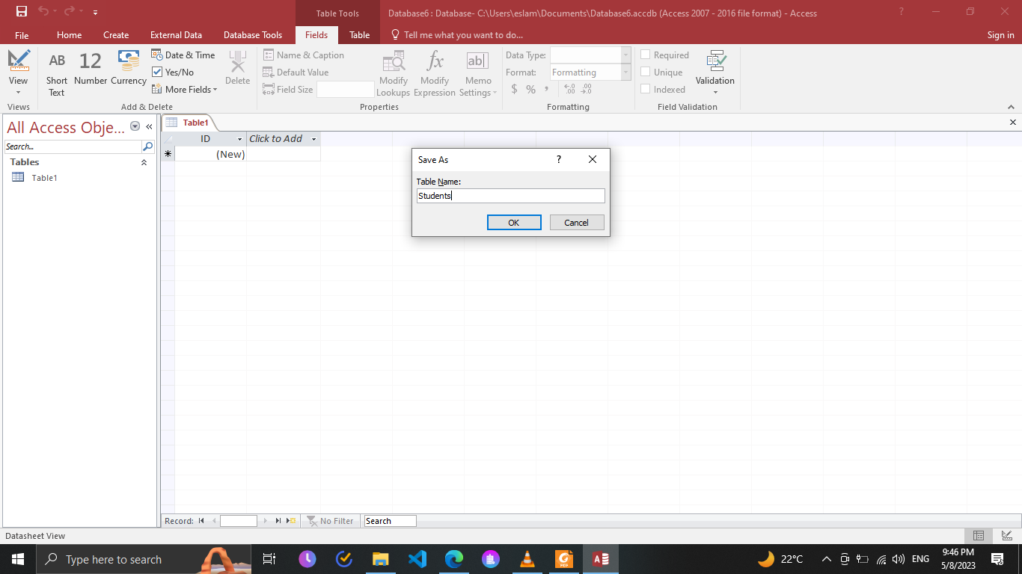

1. Fill the table designing

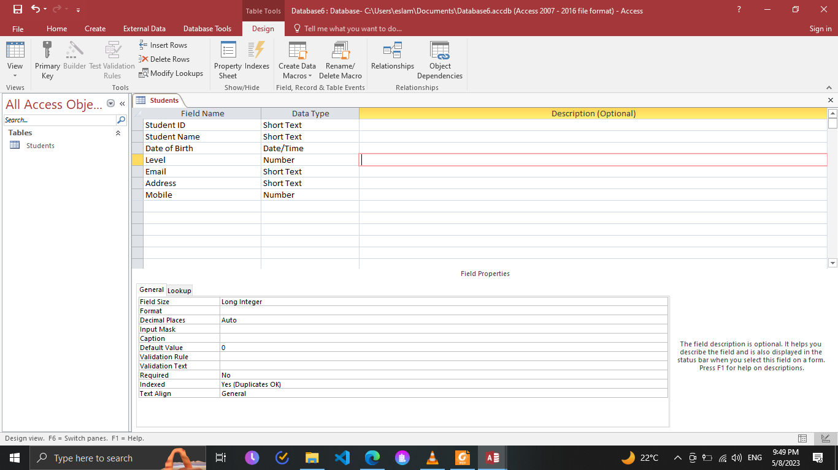

1. Then fill the table data

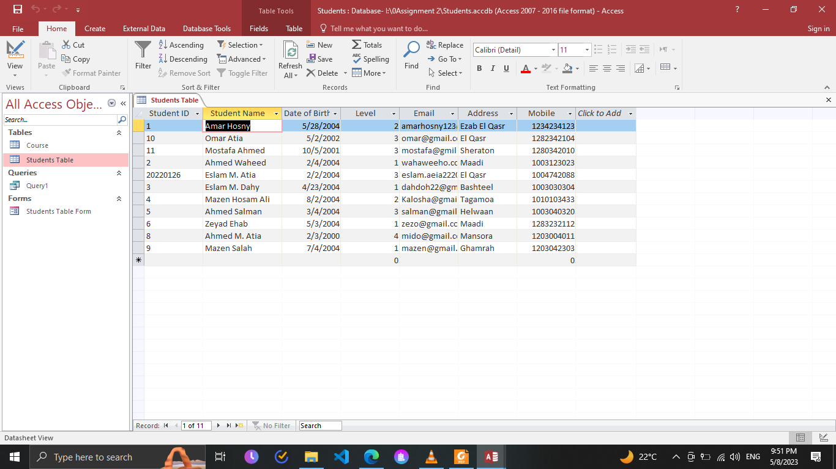

1. I created another table called Course

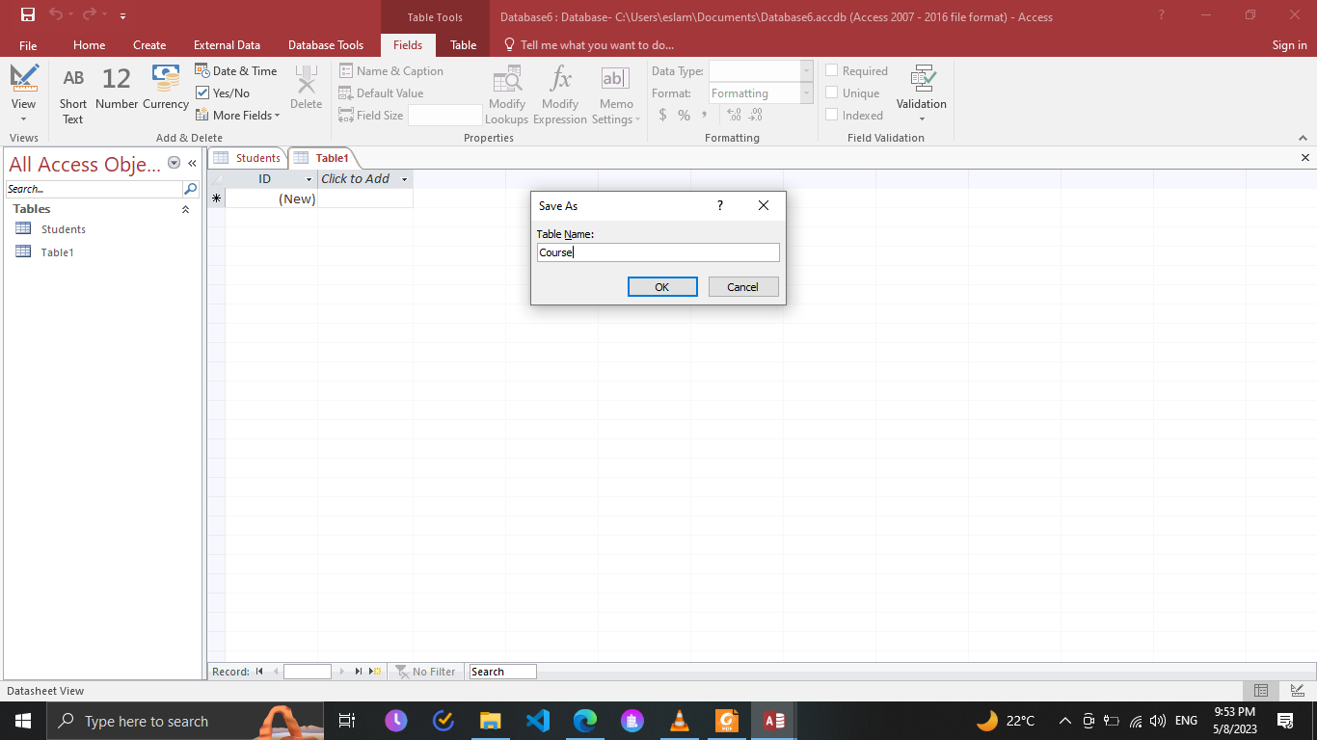

1. Fill the table design

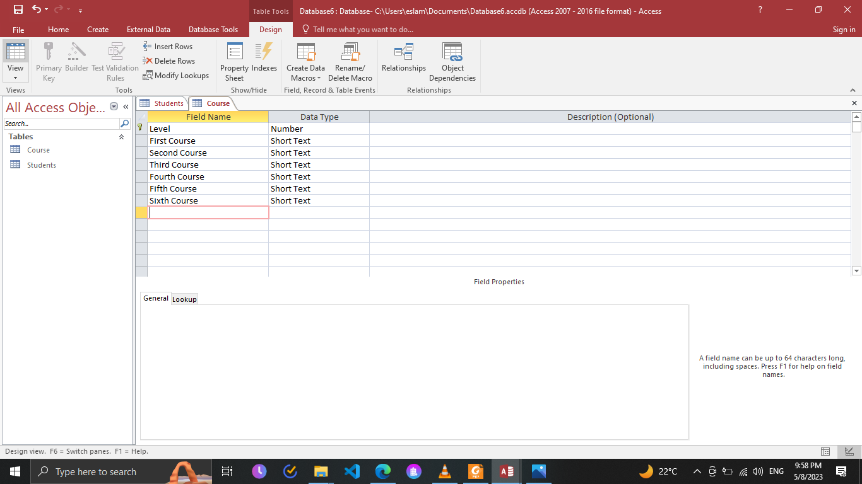

1. Fill the course table data

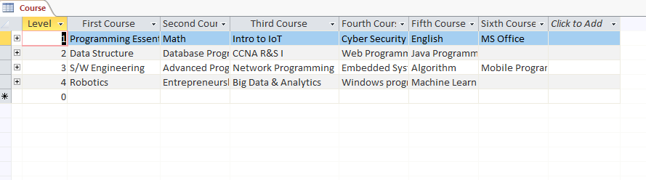11. Then I created a relation between course table and students table (1-many)

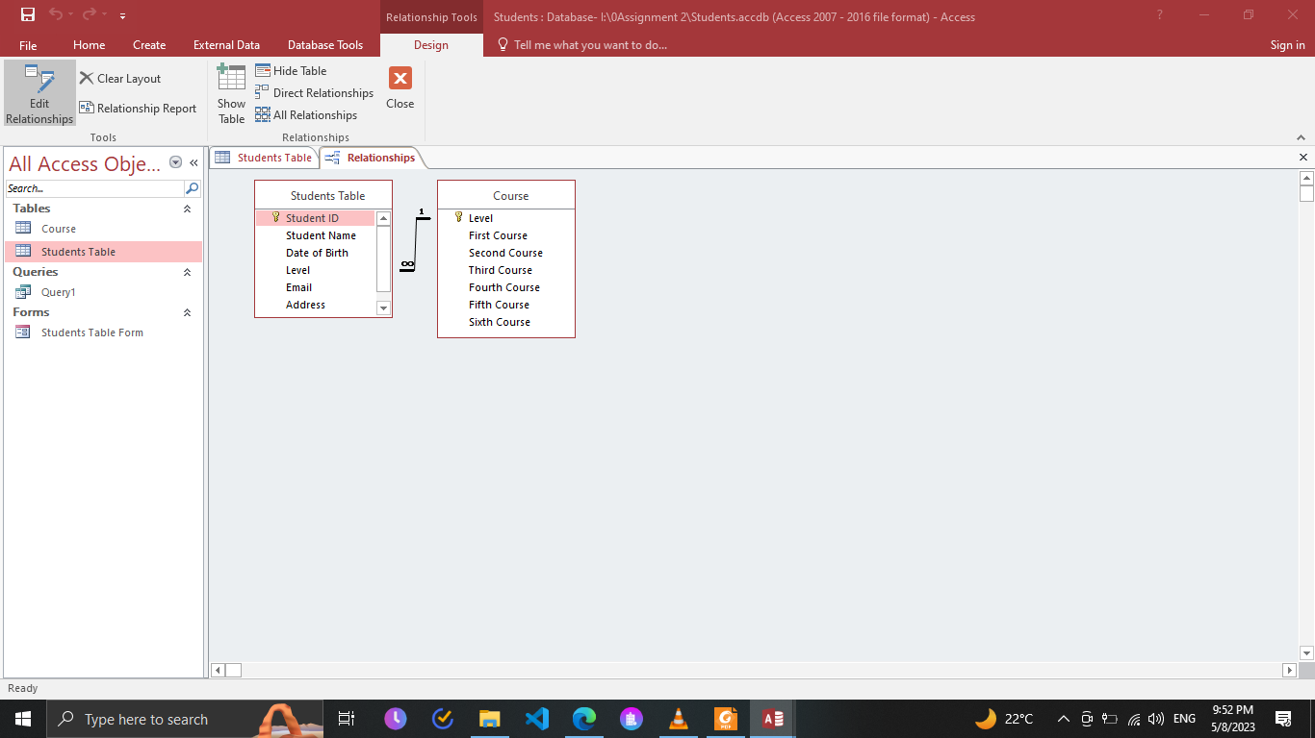

1. I created a query

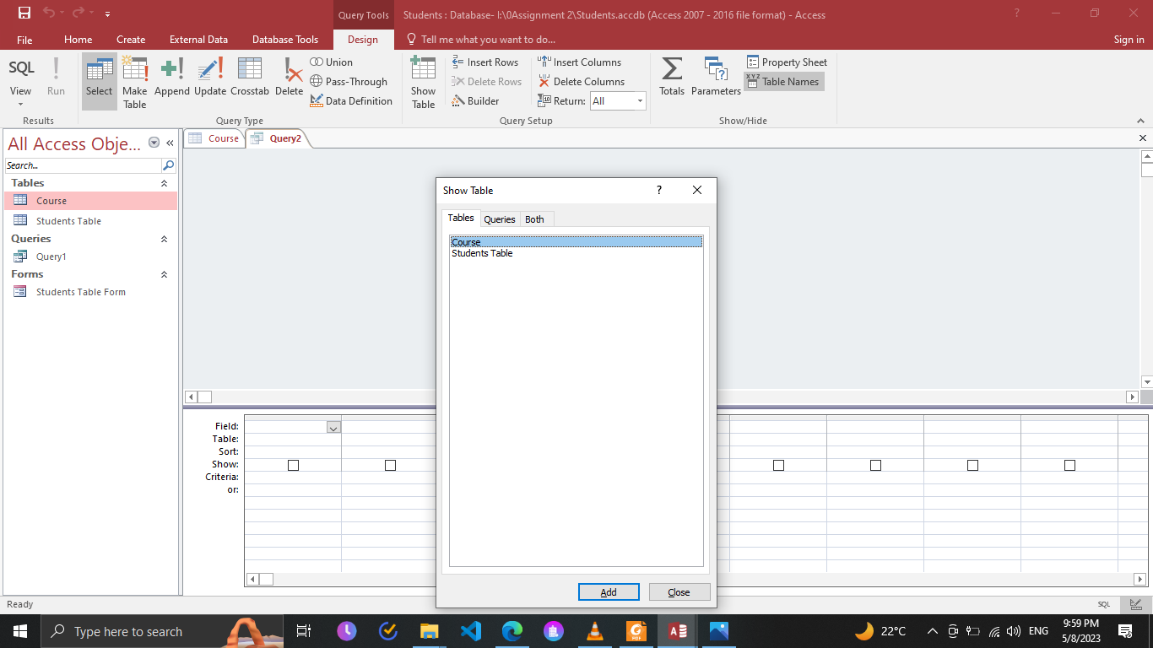

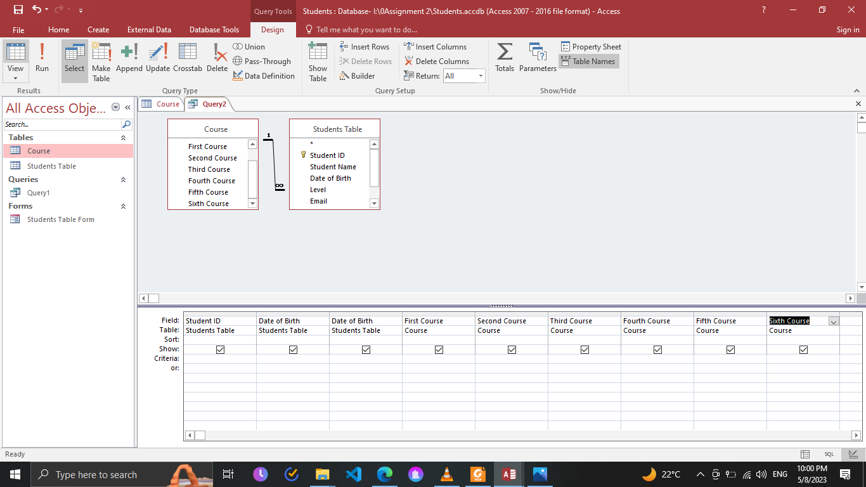

13. I created 2 forms to course table and students table

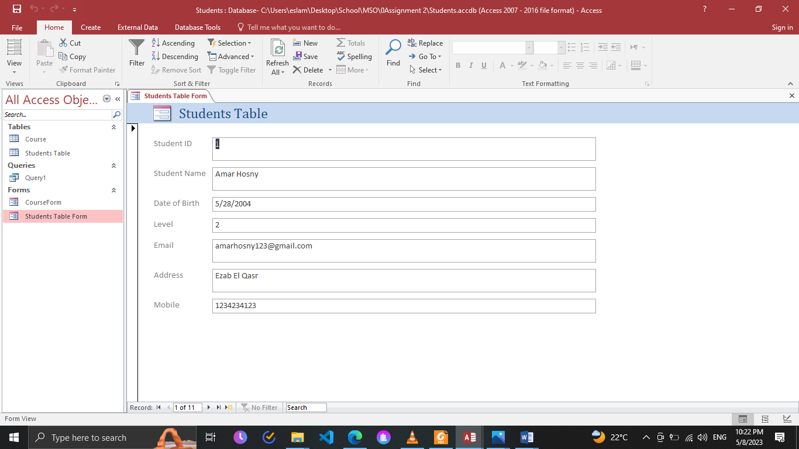

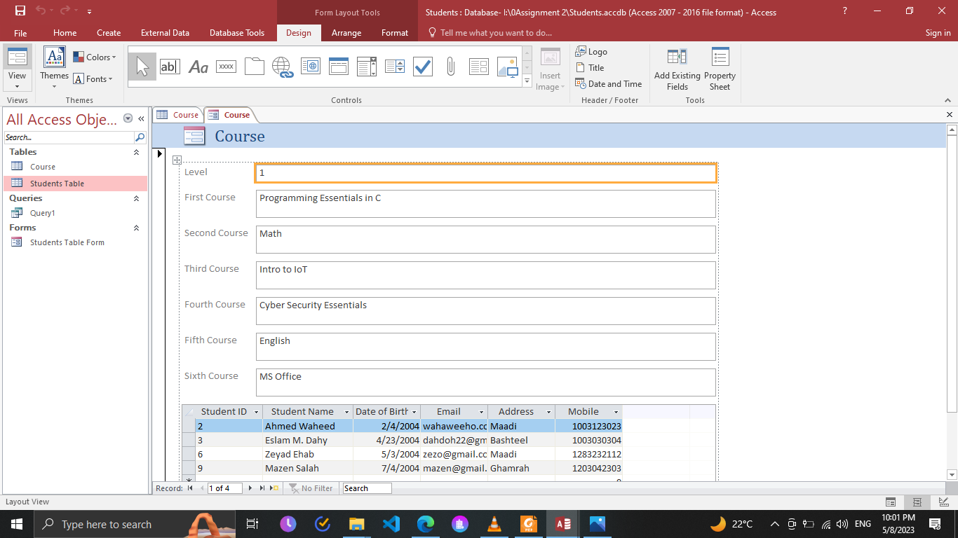

To delete a database file in Access, follow these steps:

1. Close the database file in Access.
2. Navigate to the location where the database file is saved.
3. Right-click on the file and select "Delete."
4. Confirm that you want to delete the file by clicking "Yes."

## **Evaluate database table’s relationship.**

**One-to-one** relationships exist when each record in one table is related to exactly one record in another table. This type of relationship is rare, as it is usually more efficient to combine the two tables into a single table.

**One-to-many** relationships exist when each record in one table can be related to multiple records in another table. For example, a customer can have multiple orders, but each order belongs to only one customer. In this case, the "customer" table is the "one" side of the relationship and the "order" table is the "many" side of the relationship.

**Many-to-many** relationships exist when each record in one table can be related to multiple records in another table, and vice versa. This type of relationship requires a third table, called a junction table, to store the relationships between the two tables. For example, a student can take multiple courses, and a course can have multiple students. In this case, the "student" table and the "course" table have a many-to-many relationship, and the junction table would store the relationships between the two tables.

# **Task 2**

## **Carry out Microsoft PowerPoint to create and modify presentation files. Describe**

## **the functions of the Microsoft PowerPoint application.**

Microsoft PowerPoint is a presentation program that allows users to create and modify slideshows, also known as presentations. Its main function is to provide an interface for creating and presenting professional-looking slideshows that can be used for a variety of purposes, such as business presentations, educational lectures, and training sessions.

**To create a new presentation file in Microsoft PowerPoint, follow these steps:**

1. Open Microsoft PowerPoint.
2. Click on "New Presentation" or select a template to use.
3. Choose a theme or design for the presentation.
4. Add slides to the presentation by clicking on "New Slide" or using a pre-designed layout.
5. Add content to the slides, such as text, images, and charts.
6. Add animations and transitions to the slides as desired.
7. Save the presentation file.

**To modify an existing presentation file in Microsoft PowerPoint, follow these steps:**

1. Open the presentation file in Microsoft PowerPoint.
2. Navigate to the slide you want to modify.
3. Make changes to the content of the slide, such as adding or deleting text or images.
4. Modify the design of the slide by changing the theme or layout.
5. Add animations or transitions to the slide as desired.
6. Save the changes to the presentation file.